Lab 1

- Terraform installed successfully
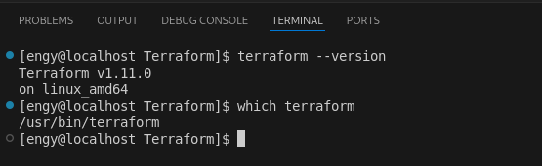

- Created a user name terraform-user in AWS Console and gave it Administrator access
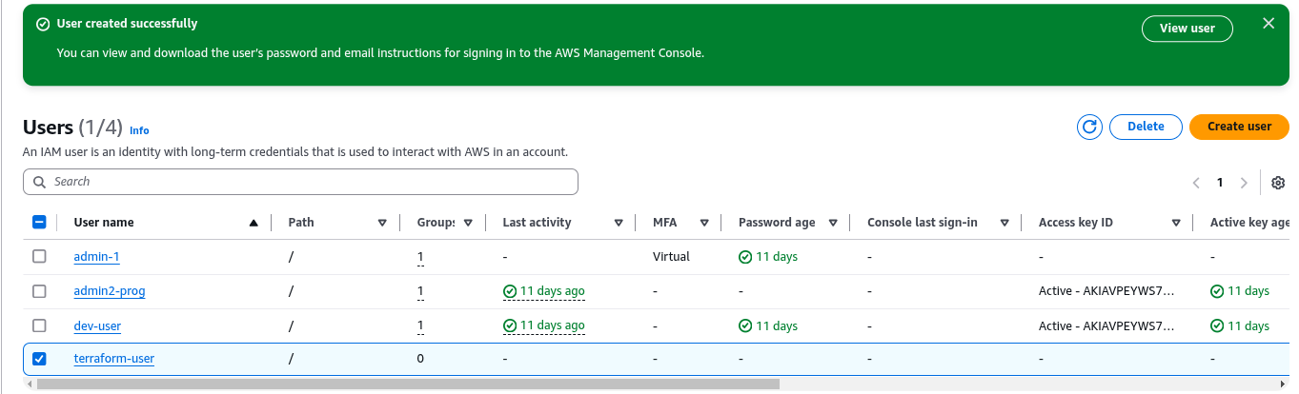
- Generate the access keys for this user
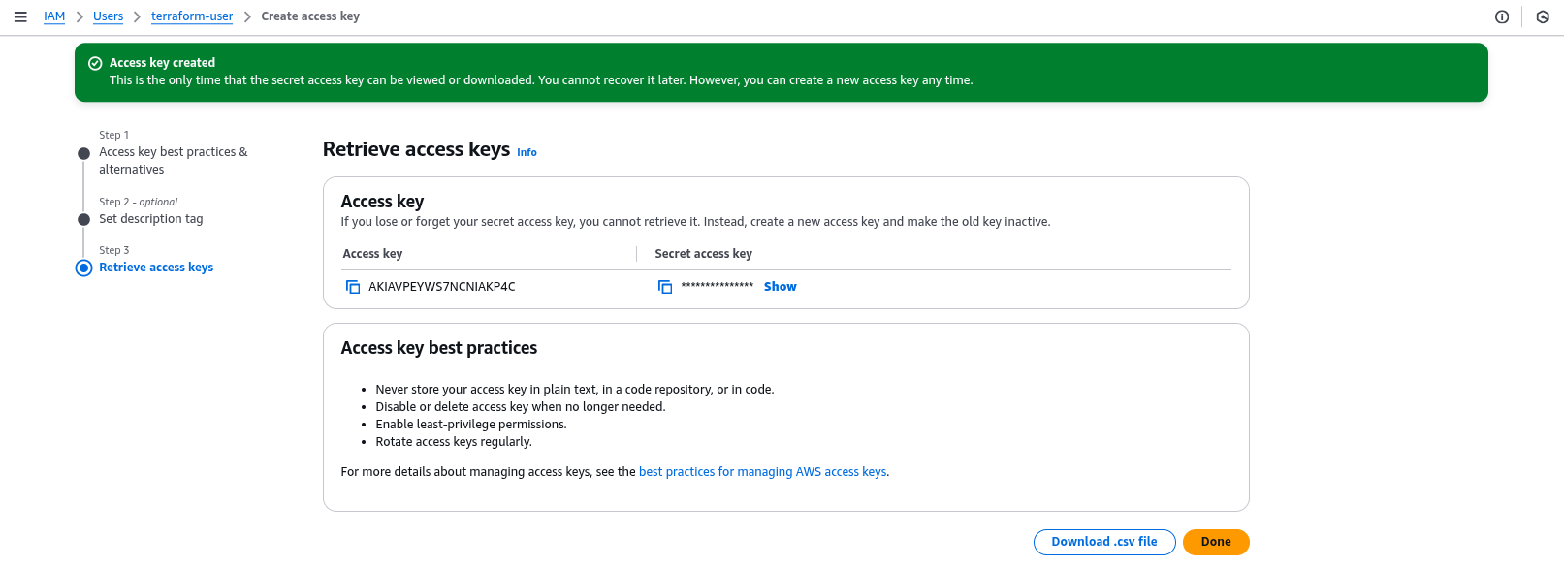
- AWS Configure

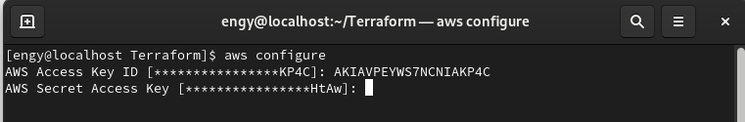
- Made a profile named terraform in my ~/.aws/credentials file

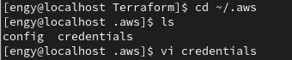

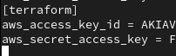

- Used terraform init to initialize my terraform plugins
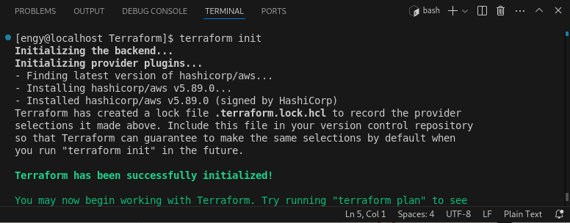
- Created gitignore file and added in it all the plugins
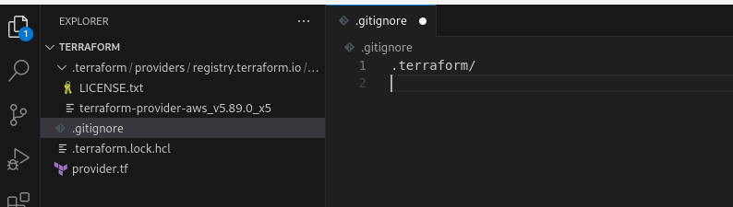
- Created provider file and used in it the terraform profile that has the accesskeys that we added.
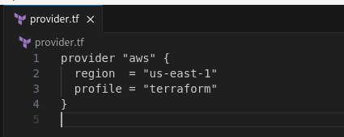

- Created a s3 bucket named terraform-bucket-engy
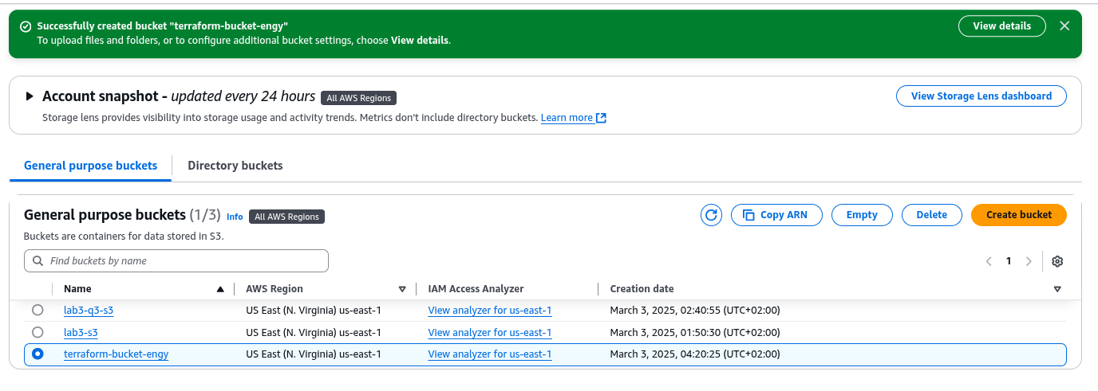
- Created a backend.tf file and added my bucket name “terraform-bucket-engy “ and the key that will be created inside of it .
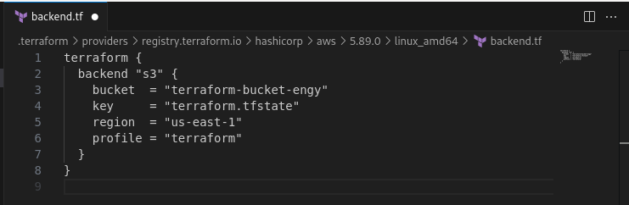
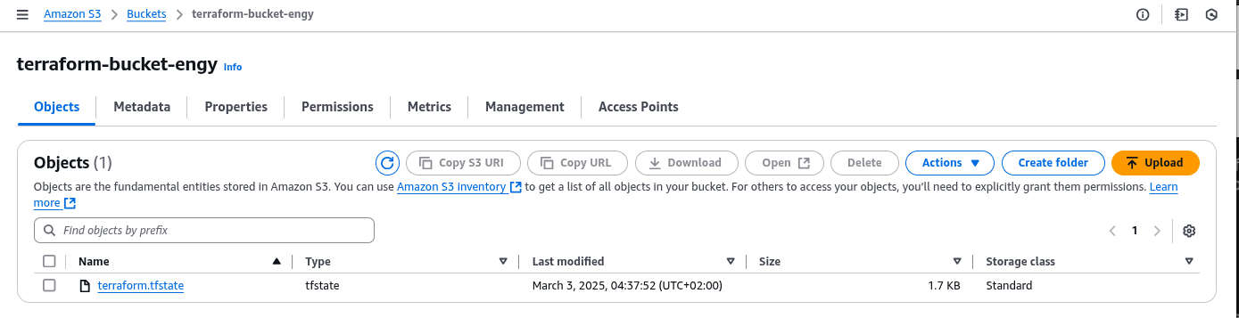
→ was created after terraform apply command

1- create vpc
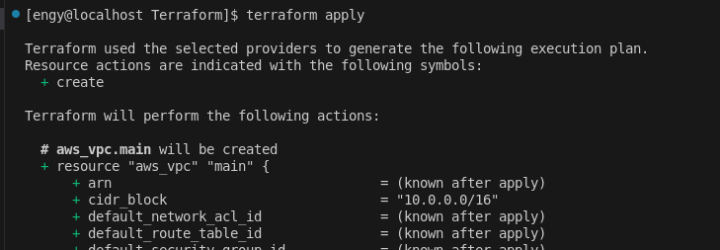
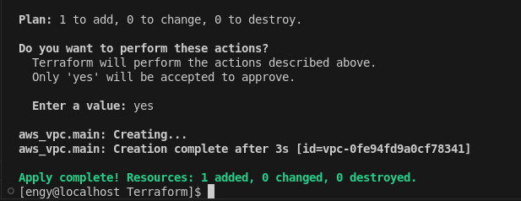
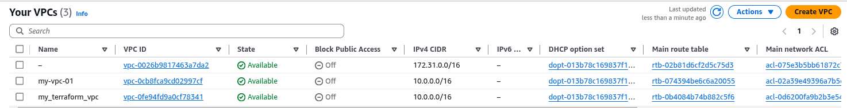
2- create internet gateway
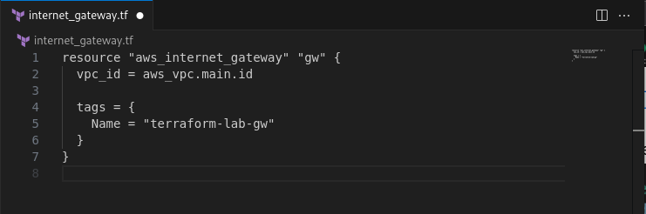
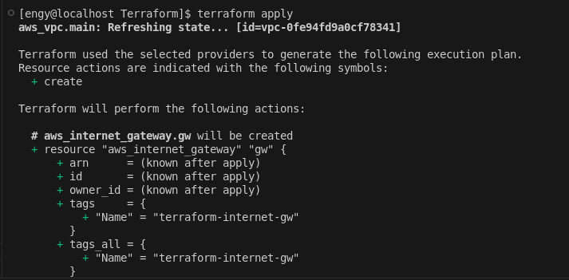
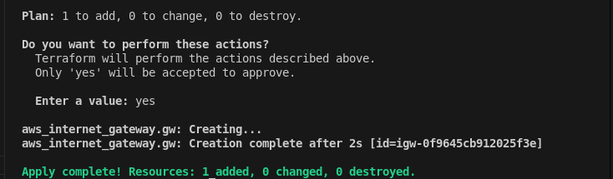
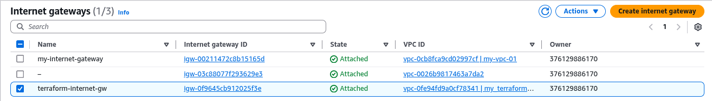
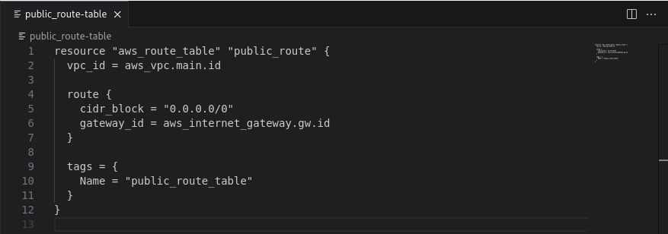
3- create public route table
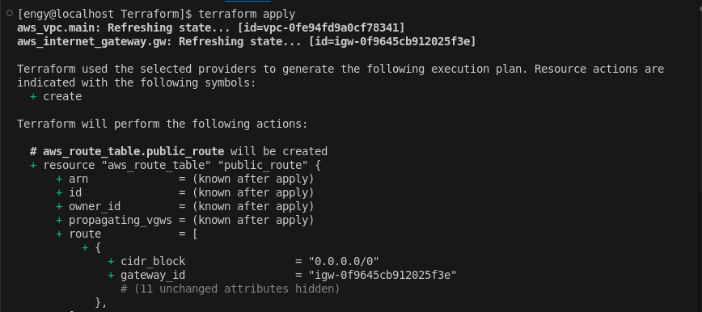
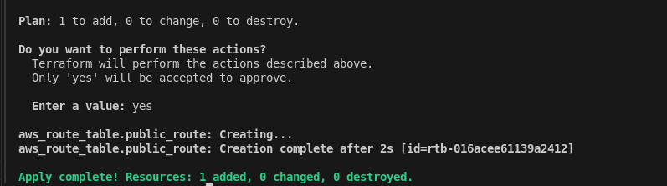
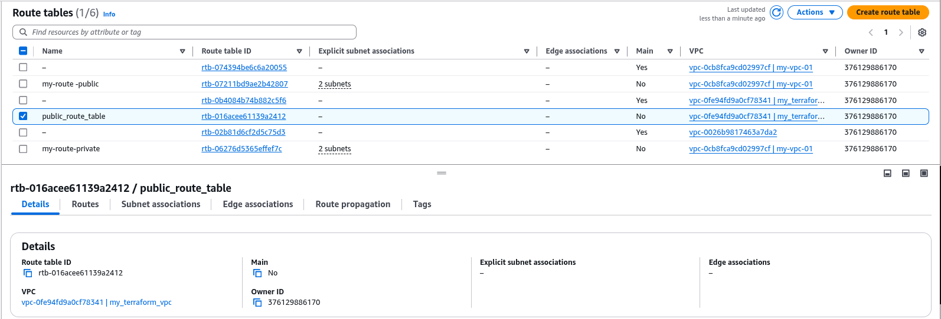

4- create private route table

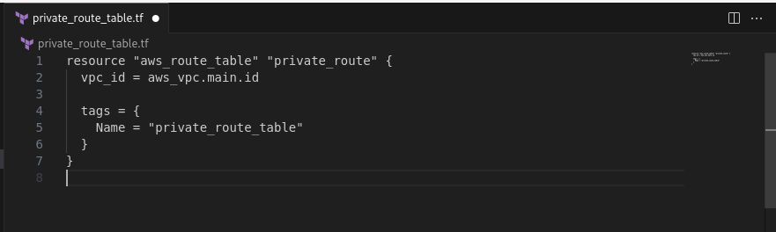
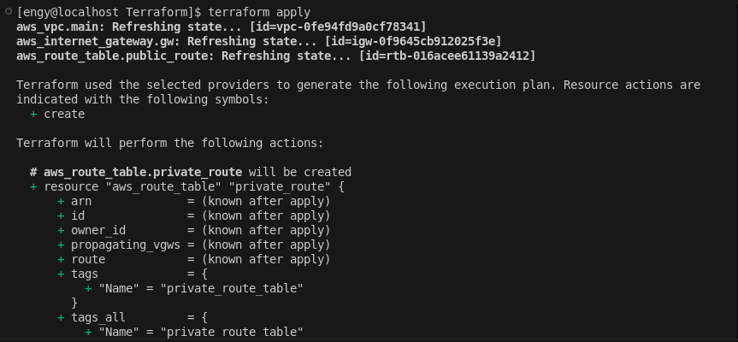
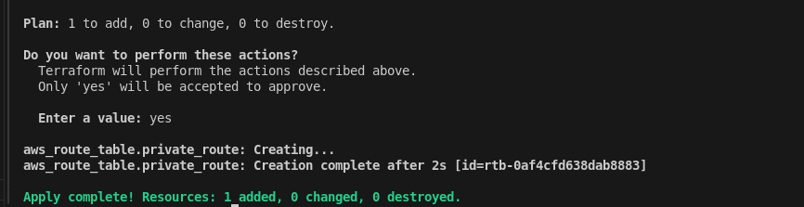
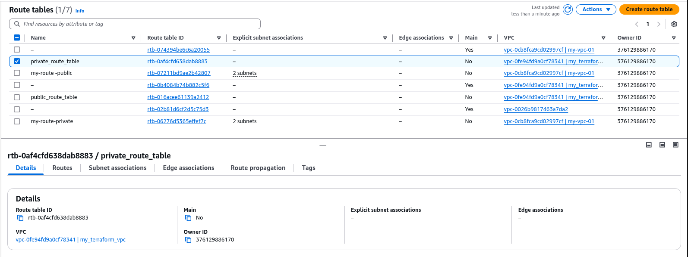
5- create public route
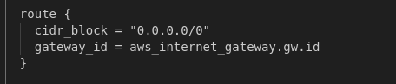

- Create two subnets ( 1 private and 1 public )
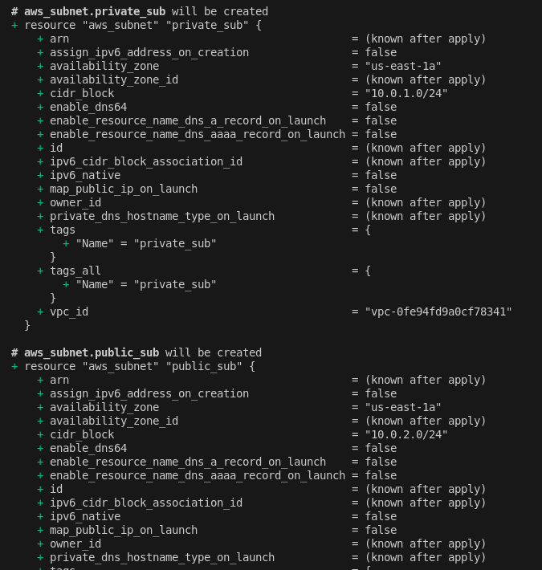

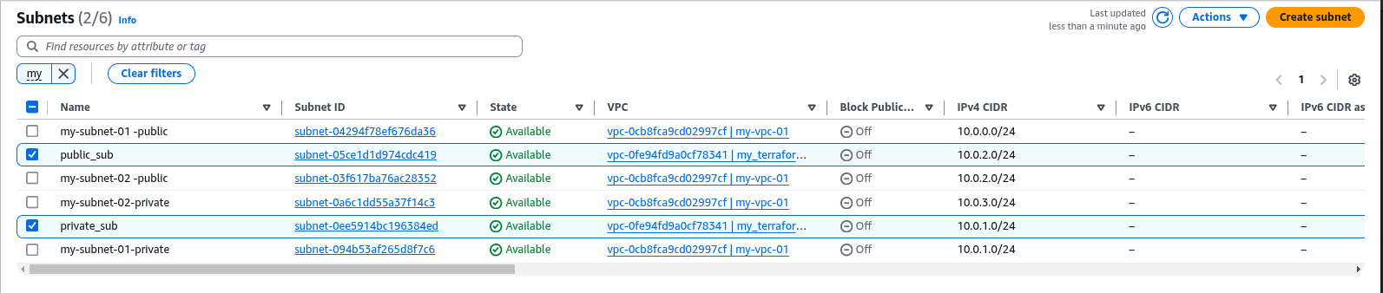
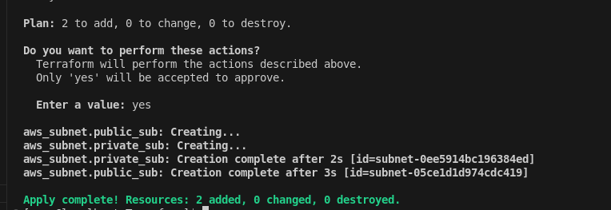

6- Attach public route table to subnets
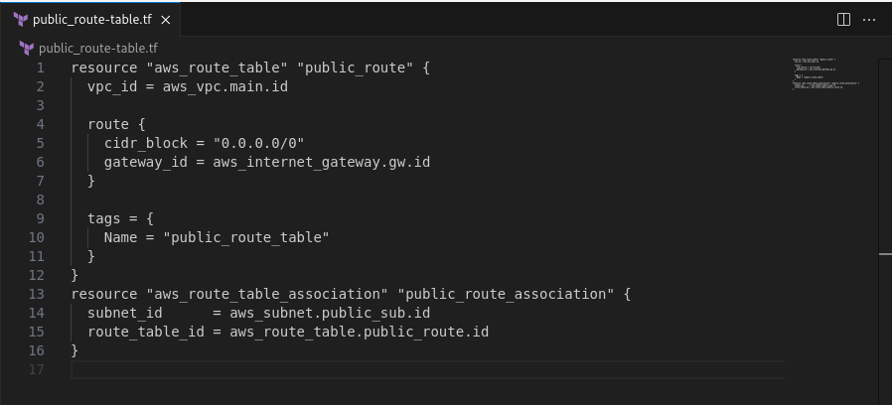
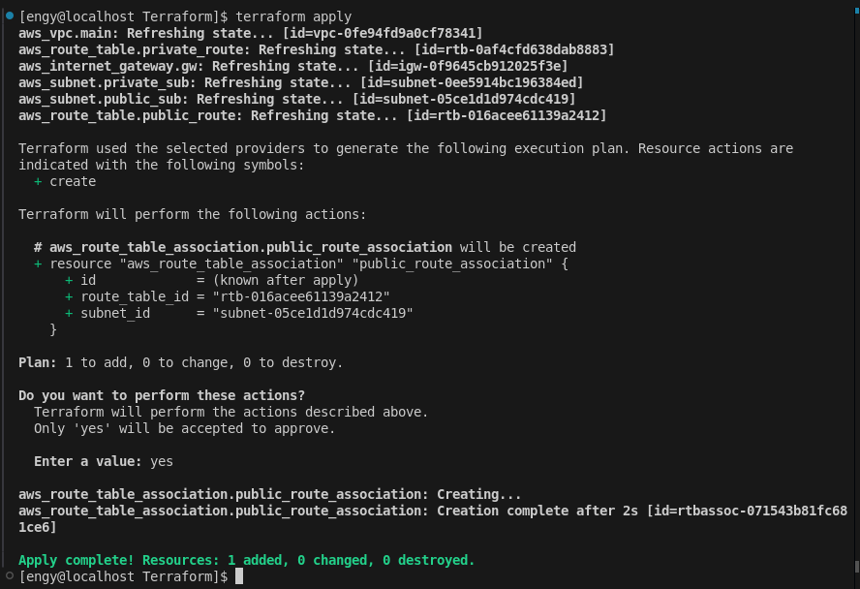
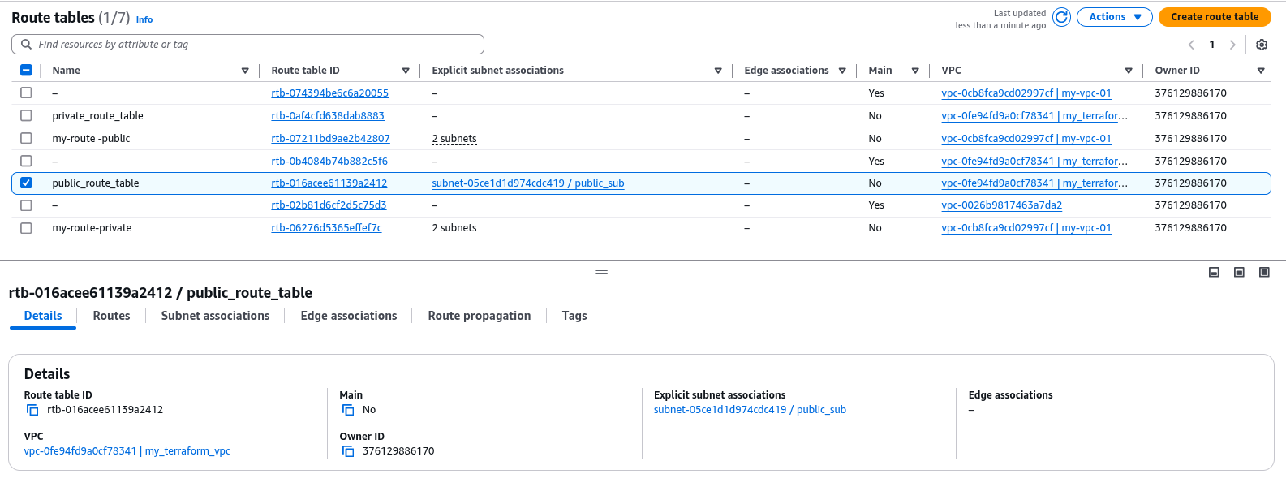

Compute

7- create security group which allow ssh from 0.0.0.0/0

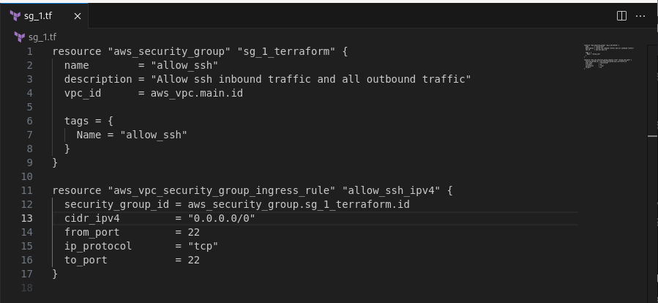
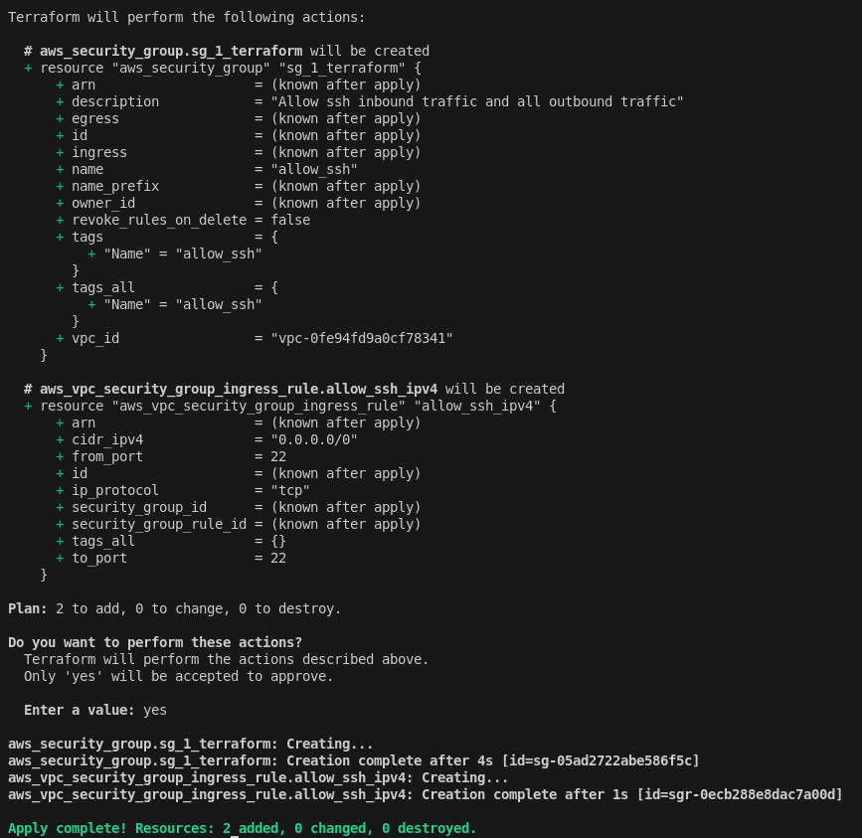
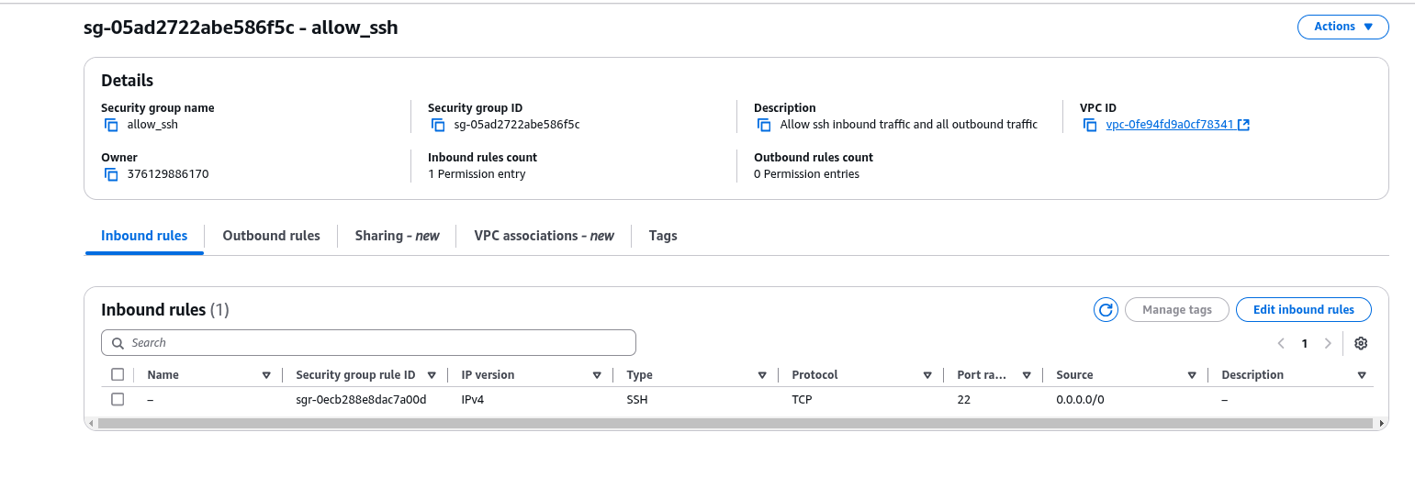
8- create security group that allow ssh and port 3000 from vpc cidr only
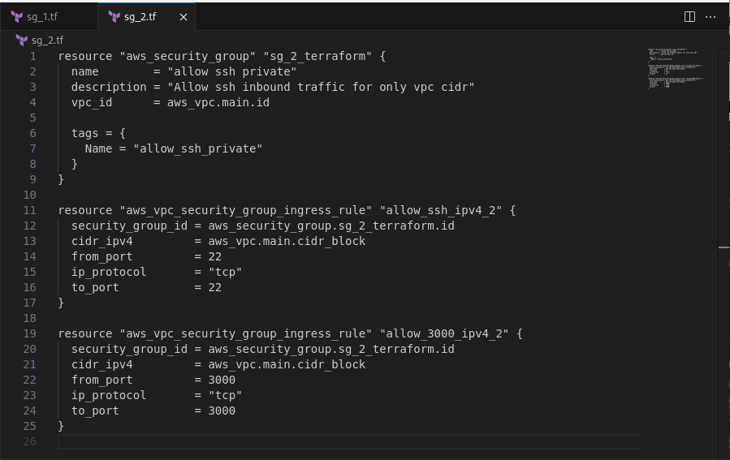
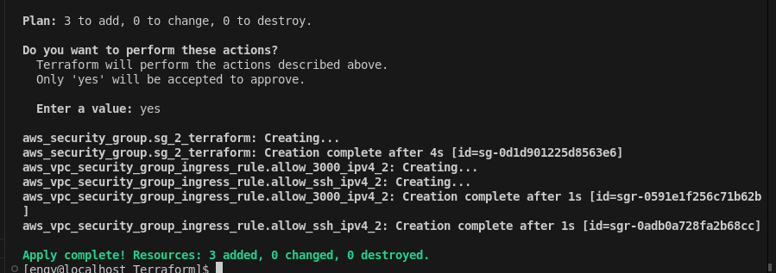
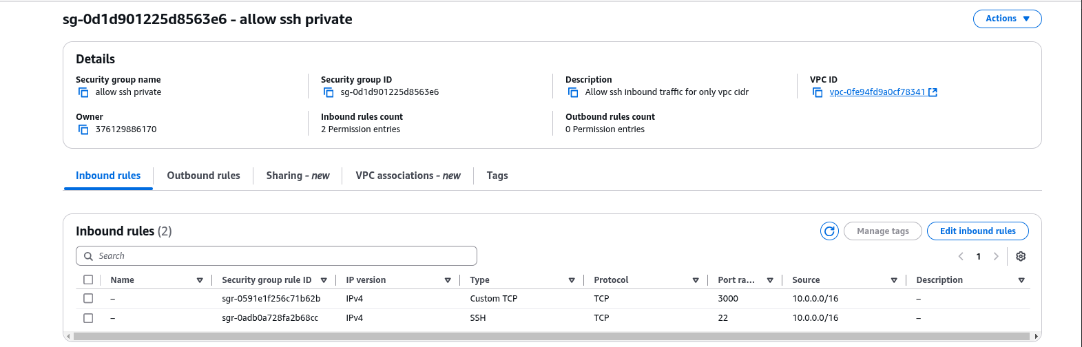

7- create ec2(bastion) in public subnet with security group from 7
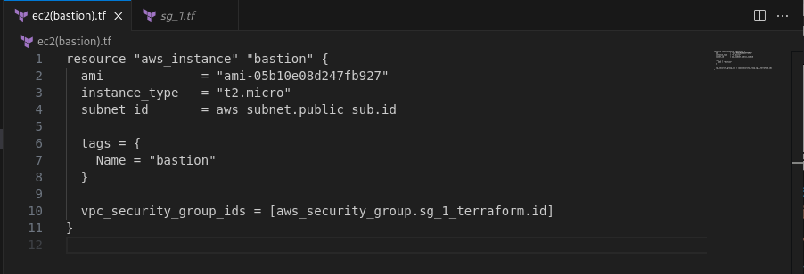
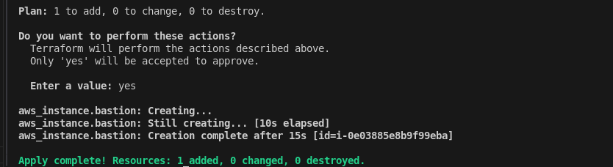

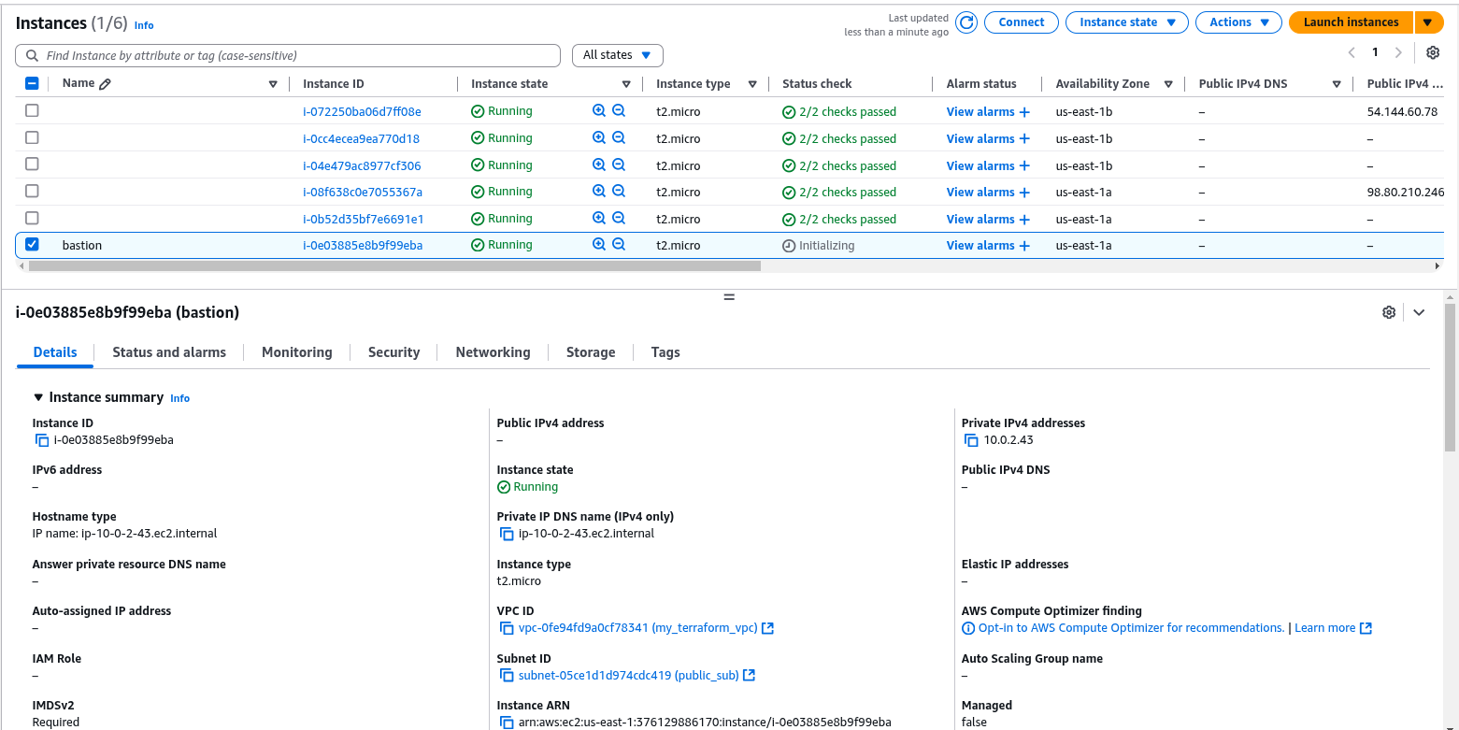
8- create ec2(application) private subnet with security group from 8
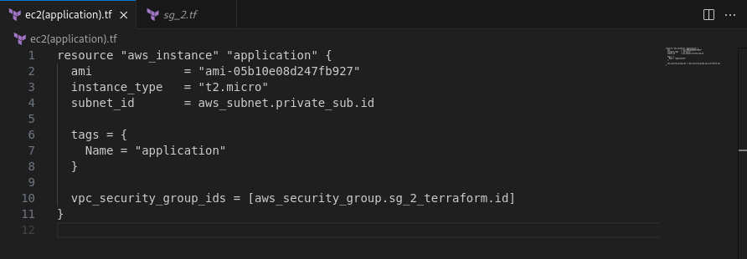
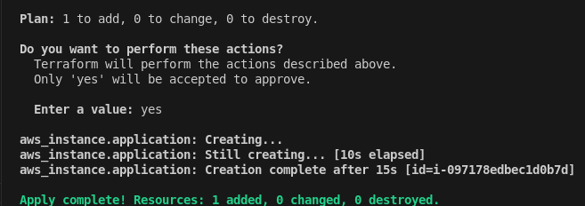

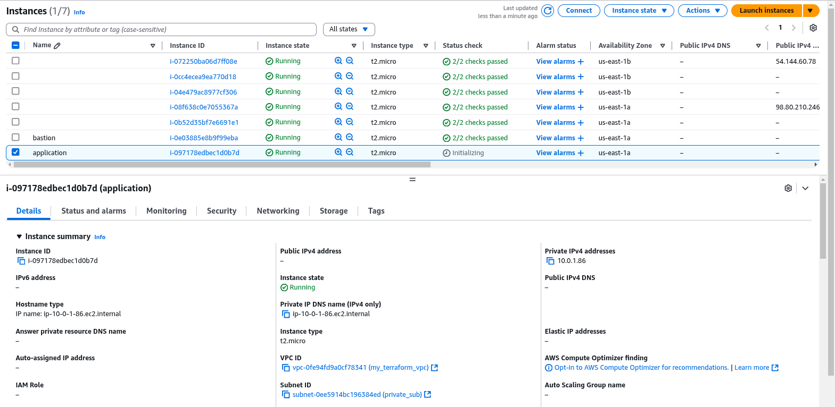
Finally , that’s all ! :)
You can access my github repo for this Lab through :
https://github.com/EngyElhamzawy/Terraform_Labs

